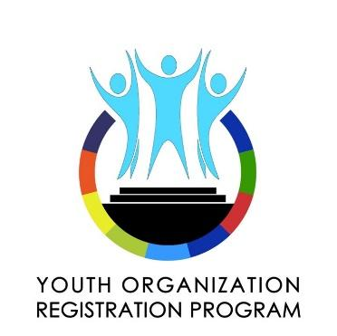
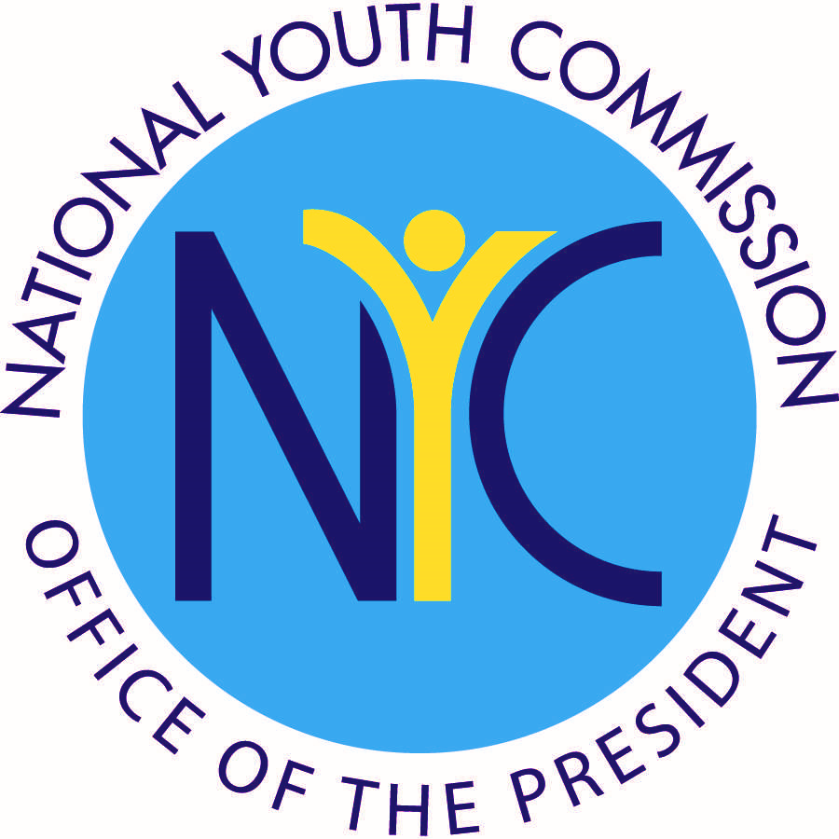
Office of the President of the Philippines
National Youth Commission
“The Voice and Advocate of the Youth”

YOUTH ORGANIZATION REGISTRATION PROGRAM

ORGANIZATION PROFILE
Name of Organization

Organization’s Address

Building No Street Municipality/City Province
Major Classification  Youth Organization  Youth-Serving Organization | Sub-Classification  Community-based  School-based  Faith-based  Consortium/Federation |  | Advocacies  Education  Environment  Health  Peace Building & Security  Governance  Active Citizenship  Global Mobility  Social Inclusion & Equity  Economic Empowerment
Organizational Level

National Organization

Inter-Regional Organization

Regional Organization

Provincial Organization

City/Municipal Organization

Organizational Contact Number/s  Telephone:  Cellphone: |  |  | Official Organizational Email Address
Current Number of Registered Members |  |  | Date of Establishment of Organization
DEFINITIONS
Major Classification. – Organizations registering under this program shall be classified primarily into:
- YOUTH ORGANIZATION – shall refer to an organization with members in good standing entirely composed of the youth, whose ages range from fifteen (15) to thirty (30) years old with a core advocacy that serves the youth.
- YOUTH SERVING ORGANIZATION – shall refer to registered organization with members in good standing¹ whose principal programs, projects and activities are youth-related and youth-oriented, and whose composition are not limited to the youth. The organization should be duly-recognize3d or accredited either by proper national or local government registering entities.

Organizational Level. – Registering organizations shall be classified according to their scope of membership and operations, as follows:
- NATIONAL ORGANIZATION – a youth organization or youth-serving organization with members coming from the three (3) island groups, and whose major programs are national in nature and scope
- INTER-REGIONAL ORGANIZATION – a youth organization or youth-serving organization with members coming from at least two (2) regions but not from the three (3) island groups, and whose major programs are either regional or national in nature and scope.
- REGIONAL ORGANIZATION – a youth organization or youth-serving organization with members coming from at least two (2) provinces within a region and whose major programs are regional in nature and scope
- PROVINCIAL ORGANIZATION – a youth organization or youth-serving organization with members coming from at least two (2) cities and/or municipalities of a province and whose major programs are provincial in nature and scope
- CITY/MUNICIPAL ORGANIZATION – a youth organization or youth-serving organization with members coming from at least two (2) barangays of a city or a municipality and whose major

Sub-Classification. – Registering organizations shall be further classified according to the majority of its membership, as follows:
- COMMUNITY-BASED ORGANIZATION – refers to a youth organization or youth-serving organization whose programs, projects and membership are based only in a certain locality or community.
- FAITH-BASED ORGANIZATION – refers to a youth organization or youth-serving organization whose membership belongs to a certain religion or sect or religious belief.
- SCHOOL-BASED ORGANIZATION – refers to a youth organization or youth-serving organization whose membership are students belonging to schools, universities or colleges legally recognized by the state.
- CONSORTIUM/ FEDERATION – a youth organization or youth-serving organization whose members are at least two (2) youth organizations and youth-serving organizations which agreed to consolidate their efforts to pursue a common interest.
BRIEF DESCRIPTION & OBJECTIVES (maximum of 300 words only)
LEADERSHIP & MEMBERSHIP INFORMATION
Name of Head of Organization  Family Given Middle |  | Name of Adviser  Family Given Middle
Contact Number / Mobile Number |  | Contact Number / Mobile Number
Email Address |  | Email Address

ATTACHMENTS / REQUIREMENTS
This Official Registration Form shall be accompanied by the following: (Please check tip box if complied)

DIRECTORY OF OFFICERS AND ADVISERS

LIST OF MEMBERS IN GOOD STANDING

COPY OF CONSTITUTION AND BY-LAWS (should indicate the age and scope of membership)

ENDORSEMENT/CERTIFICATION FROM APPROPRIATE AUTHORITY
For Community-Based Organizations (submit one of the following)
If organization has a physical office, Certification of Existence of Office from the barangay where the office is located

If organization does not have a physical office, Barangay Certification of Residence of the President

Resolution of endorsement coming from the Sangguniang Kabataan

For School-Based Organizations
Certificate of Registration or Recognition from a competent school authority supervising student affairs

For Faith-based organizations
Certificate of Registration or Recognition from any head/pastor of congregation or parish priest

For chapters of multi-level organizations
Certificate of Registration or Recognition from the president governing at the highest organizational level

For Consortium organizations
Certification of Member Organizations issued by the secretariat/board

For organizations registered in the Local Youth Development Offices
Certificate of Registration and Verification

SUBMISSION OF REQUIREMENTS
The documentary requirements of registering youth organizations and youth-serving organizations may be submitted to the appropriate office:

- Those municipal or city organizations shall apply for registration at their respective Municipal or City Youth Development Office, the designated personnel, in the absence of an LYDO, or its equivalent;
- Those provincial organizations shall apply for registration at their respective Provincial Youth Development Office, the designated personnel, in the absence of an LYDO, or its equivalent;
- Those regional and national organizations, and consortiums and federations shall apply for registration to the National Youth Commission.

In the absence of a Local Youth Development Office or its equivalent in a certain local government unit, the organization may apply for special registration and verification with the National Youth Commission. The president of the organization shall put into writing, addressing to the NYC Commission Proper through the YORP Secretariat, their request for special registration and verification:

- The YORP Secretariat
c/o Regional Youth Development Division
National Youth Commission
3rd Floor West Insula Building, No. 135 West Avenue cor. EDSA, Quezon City
Contact number: (+432)426 8760 loc. 103

- NYC Area Offices in Baguio, Naga, Cebu, Zamboanga, Davao and Cagayan de Oro
(Addresses of area offices are up in our website at www.nyc.gov.ph)

HOW DID YOU KNOW ABOUT YORP?
Newspaper / Radio / Television NYC Website NYC Communication

Referred by: NYC Official / Personnel , please identify _______________________________________________

Others, please identify ________________________________________________________________________

UNDERTAKING
We hereby signify our desire to seek registration with the National Youth Commission (NYC) pursuant to Republic Act No. 8044 and Republic Act No. 10742. For this reason, we hereby undertake to swear that:

- The information contained herein and the attachments are true and correct;
- We consent that the information supplied in this Application for Registration be posted online or printed as part of the official list of registered and verified youth organizations and youth serving organizations to be published by the National Youth Commission;
- We have read and understood in full the Policy Guidelines in the Registration of Youth Organizations and Youth-Serving Organizations (2017 Youth Organization Registration Program Guidelines), and agree to abide by its provisions;
- Should the organization commit any violation of the Philippine Constitution or laws of the land or rules and regulations of duly constituted authorities and/or violation to any policy, resolution, or rules and regulations of the National Youth Commission, our registration may be suspended or revoked.

We, the undersigned, expressly authorize the National Youth Commission or its representatives to use, share and process personal information that we have provided, shared or declared in this form/document for any lawful purpose.

__________________________________________ __________________________________________
President / Head of Organization Adviser
(Printed name and Signature) (Printed name and Signature)

Date of filing: _________________

